S.I. Mini quiz: Knowledge Assessment.
Name:

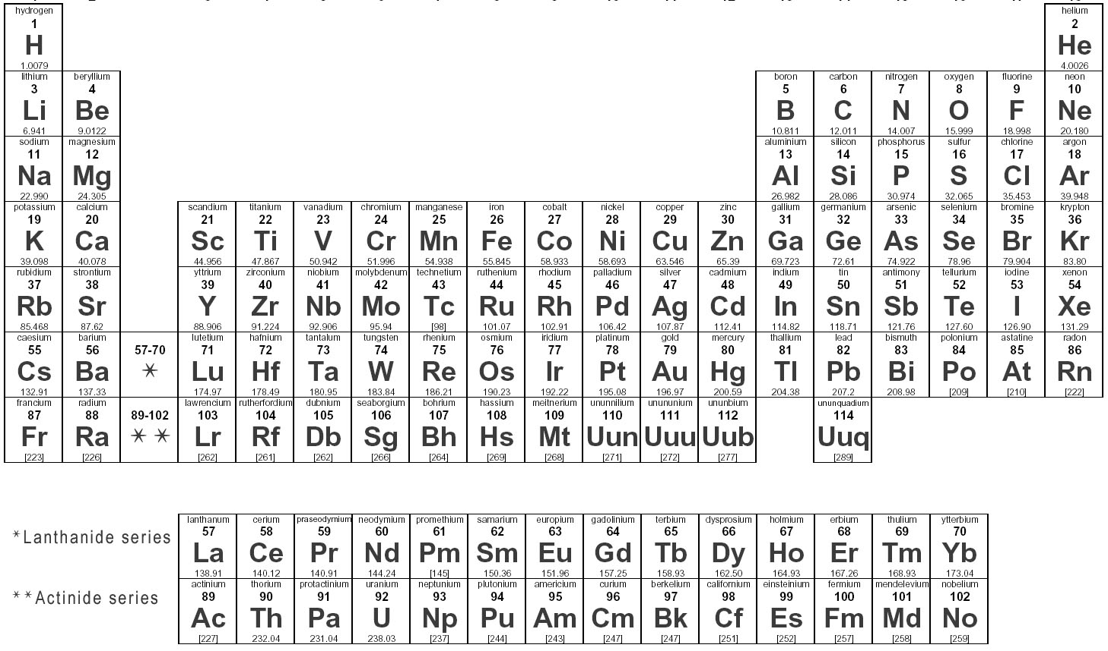

Understanding the Periodic table
1) Which of the following is the most electronegative element on the periodic table of elements?
A) Oxygen
B) Caesium
C) Francium
D) Fluorine

2) Which term best explains the relationship between Cu (Copper) – 63.54amu and Cu – 65.98amu?
A) Isomers
B) Enantiomers
C) Isopaths
D) Isotopes

3) Which term best describes the relationship between Be, Mg, Sr, and Ba?
A) All react vigorously with liquid Zn.
B) All are alkaline earth metals
C) Have the same number of valence electrons
D) A & C are correct
E) B & C are correct
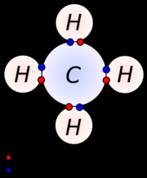
4) What kind of bonding is occurring in the compound to the right?
A) Ionic bonding
B) Covalent bonding
C) Metallic bonding
D) More than one answer is correct
5) Which of the following is non-polar overall?
A) 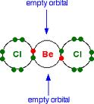 B) 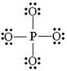 C) 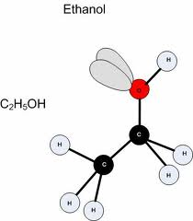 D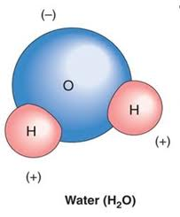

E) More than one is correct

6) Which of the following will dissolve in a hydrophilic solvent?
A) B) C) D) 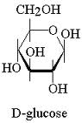
E) More than one is Correct

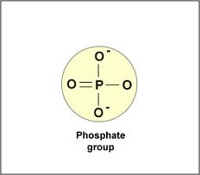
(Please remember that the Phosphate group is highly polar and
always written different than shown above in questions 5 & 6.
Image and formula listed below. However, answer questions
5 & 6 based on the structures given.)
OPO₃²⁻
7) The amount of heat that must be absorbed or lost for 1g of a substance to change its temperature by 1 degree.
A) Calorie
B) Heat
C) Specific Heat
D) Heat of vaporization
Basic Scientific Chemistry
8) Calcuate the molarity when 75.0 grams of MgCl₂ is dissolved in 500.0 mL of solution.
A) 1.57 M
B) 0.00157 M
C) 0.788 M
D) 393.90 M

9) 100.0 grams of sucrose is dissolved in 1.50 L of solution. What is the molarity? (Formula for sucrose is C₁₂H₂₂O₁₁)
A) 0.292 M
B) 3.26 M
C) 1.195M
D) 0.194M

10) A 6 g of Sucrose is dissolved in 350 mL of water. What is the Molarity of the final solution? (Formula for sucrose is C₁₂H₂₂O₁₁)
A) 0.0501M
B) 5 x 10 ^ -5 M
C) 0.350 M
D) 0.1501 M

11) How many grams of KMnO₄ are needed to make 500.0 mL of a 0.200 M solution?
A) 0.1g
B) 15.8g
C) 15800g
D) 1.58g
12) Which of the following elements are capable of forming a Hydrogen (H) bond in the presence of Hydrogen?
A) Oxygen
B) Nitrogen
C) Carbon
D) A & B
E) B & C

Group Work Questions
13) Milk of Magnesia has an approximate pH of 10, what is the [H] (hydrogen ion concentration) and pOH of milk of Magnesia?

14) Human blood has an average pH of 7.4 under normal physiological conditions. What is the Molarity of Hydrogen ions in human blood?

