Eye See You
Name:

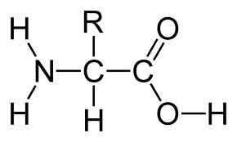
- A) Amino acid
B) Nucleic acid
C) Carboxylic acid
D) Carboxy nitrate
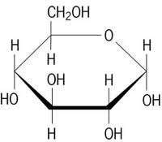
- A) Ribulose
B) Dihydroxyacetone
C) Ribose
D) D-glucose
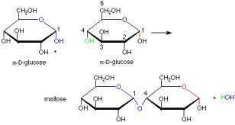
- Identify the chemical reaction taking place.
- Hydrolysis of glucose
- Dehydration of maltose
- Dehydration of glucose
- Hydrolysis of maltose

- Humans do not digest cellulose and it is passed through the digestive tract and eliminated with feces. What accounts for the fact that animals such as cows and goats are able to digest cellulose in grass?
- Herbivores have different cells lining their gastrointestinal tract that are able to digest cellulose.
- Enzymes in humans that digest starch do so by hydrolyzing the beta linkages in its glycosidic bonds and these same enzymes are unable to hydrolyze the alpha – glycosidic linkages in cellulose.
- Humans are unable to convert cellulose to starch, while herbivores are able to convert cellulose into a more absorptive form such as starch, thus explaining the reasoning herbivores undergo regurgitation.
- Enzymes in humans that digest starch do so by hydrolyzing the alpha linkages in its glycosidic bonds and these same enzymes are unable to hydrolyze the beta – glycosidic linkages in cellulose.

- Indentify the bonding in the following molecules.
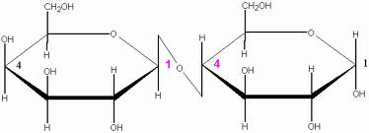
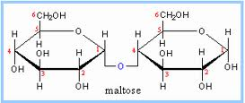
A B

- A: 1-4 Beta glycosidic, B: 1-4 Alpha glycosidic
- A: 1-4 Alpha glycosidic, B: 1-6 Alpha glycosidic
- A: 1-4 Beta glycosidic, B: 1-4 Beta glycosidic
- A: 1-4 Alpha glycosidic, B: 1-4 Beta glycosidic

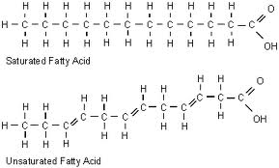

A) Saturated fatty acids (SFA) are solid at room temperature while polyunsaturated fatty acids (PUFA) are liquid at room temperature.
B) PUFA’s have higher freezing points than SFA’s.
C) SFA’s have lower boiling points than PUFA’s
D) SFA’s are liquid at room temperature while PUFA’s are solid at room temperature.
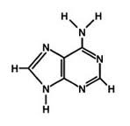
- Identify the molecule.
- Guanine
- Glycine
- Glutamine
- Guanosine

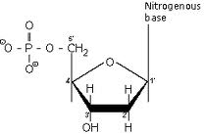
- Identify the molecule.
- RNA
- tRNA
- DNA
- rDNA
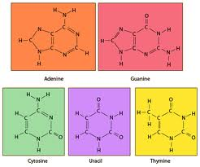
- Which of the following is not found in RNA?
- Thymine
- Uracil
- Adenine
- Cytosine

- From molecule in #9, identify the pyrimidines.
- Adenine and Guanine
- Cytosine and Guanine
- Thymine and Adenine
- Uracil and Cytosine
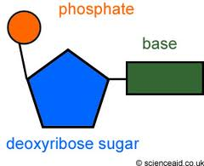
- The molecule on the right is also known as a;
- Nucleoside
- Nucleotide
- Nucleosome
- Nucleic base

