TWO TRUTHS AND A LIE
NAME:

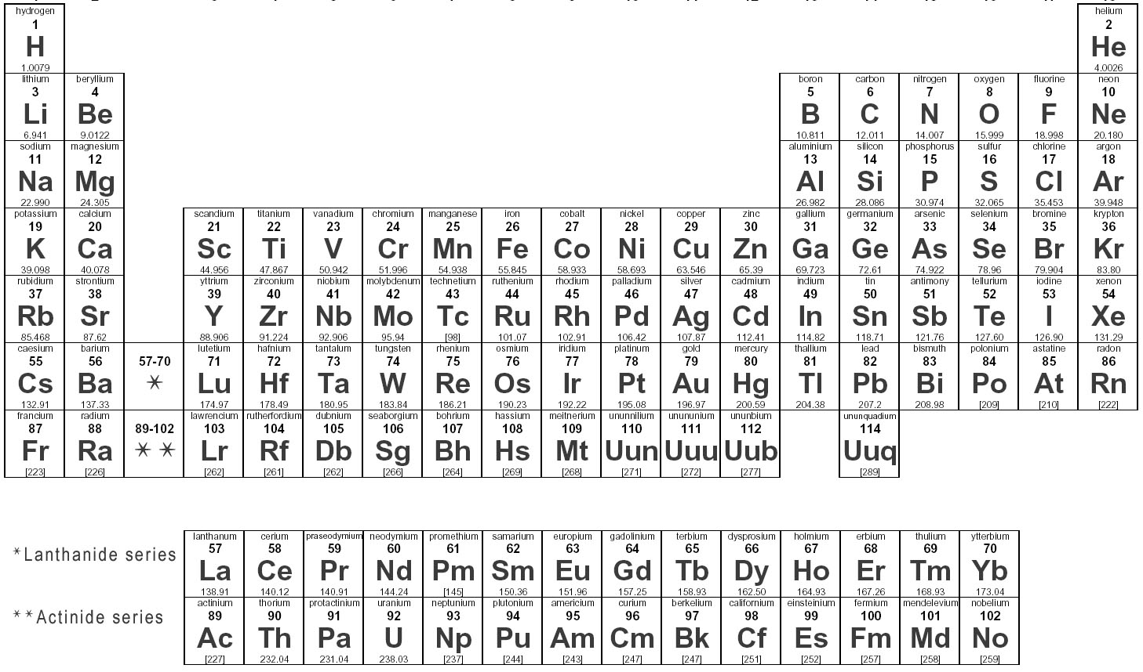

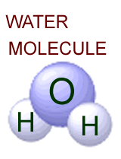
- For the Molecule on the far right:
- I am capable for forming H-bonds
- I contain very stable covalent bonds with equal clouds of electron density.
- I am able to dissociate into ions from a covalent bond.

- For the Molecule from question #1:
- At pH 7, the pOH molarity is 10⁻⁷M
- I change my temperature faster when I absorb Heat, and slower when I lose Heat, thus I am able to cool off land masses by oceans.
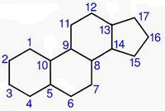
- 1g of H atoms contains 6.02 x 10²³ molecules

- For the Molecule on the far right:
- I am made up of only C and H atoms
- I am able to cross a cell membrane because I am very water loving.
- I am very stable because my C and H atoms all share electron clouds evenly.
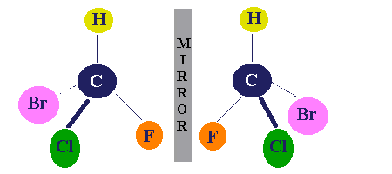
- For the Molecule on the far right:
- We are very similar in physical characteristics.
- We make great pharmaceuticals because of our similar chemistry.
- The center C is also called the asymmetric Carbon.

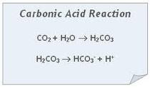
- Consider the reaction below: Assume reactions are at equilibrium.

- Increasing CO2 concentration will decrease the pH of resulting solution.
- Increasing the pOH will increase the amount of CO2 being discharged.
- This is called a Buffer solution reaction.

- Consider the following: Al³⁺
- I am also known as an anion.
- I have lost 3 electrons and I am very electropositive.
- I currently have 8 electrons in my outermost shell.

- Consider the following: O²⁻
- I have 6 valence electrons in my outer most shell.
- I have a valence number of 2
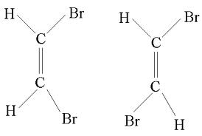
- I am highly electronegative

- Consider the Molecules on the far right:
- We are also known as structural isomers.
- The first one is called a cis and the second trans.
- We carry different chemical reactions.

- Consider a basic solution of pH 9:
- The same volume of an acid solution with pH 4 has 100,000 as many H ions.
- The pOH of the above solution is 5.
- With a high pH of 9, this solution easily donates H ions upon dilution.

- Consider the functional group: COOH – carboxyl group
- Is a source of H ions, forms covalent or H bonds, and is very polar.
- It is an important component of all amino acids.
- Can act as a base in some living organisms, by picking up H ions from solution.

