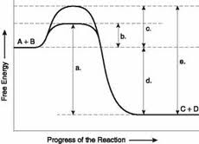
Chapter 8: Wrapping up Metabolism
Name:
Consider the diagram of the reaction on the right and answer the questions that follow below.

- Which letter represents the E_{a}, activation energy, of the overall backward reaction?
  - A.
  - B.
  - C.
  - D.
  - E
- Which letter represents the E_{a} of the catalyzed reaction?
  - A
  - B
  - C
  - D
  - E
- Which letter represents the ΔG of the reaction?
  - A
  - B
  - C
  - D
  - E
- Which letter represents the energy barrier needed to be overcomed in absence of a catalyst?
  - A
  - B
  - C
  - D
  - E
- What are the corresponding signs for the above reaction?
  - +ΔG, +ΔH, -ΔS
  - –ΔG, +ΔH, +ΔS
  - +ΔG, -ΔH, +ΔS
  - –ΔG, -ΔH, +ΔS
  - Need for information
True/False
- The ΔG of the reaction is affected by the use of an enzyme. (false)
- The top reaction is most likely associated with a catabolic pathway. (true)
- The above reaction is endothermic. (false)
- The reaction’s ΔG is spontaneous and endergonic. (false)
- The activation energy of the backward, catalyzed reaction is B, from the graph. (false)
- The ΔG of the reaction at equilibrium will be 0. (true)
- At equilibrium the work done by the reaction is constant at every given time. (False)

Short answer:

- Define allosteric regulation. How does allosteric regulation and enzyme inhibition differ? How are they similar?

- What is a coenzyme vs a cofactor? List 1 or 2 examples of each.

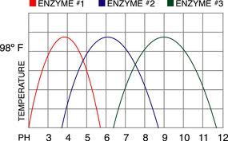

- What are the optimal pH for enzymes 1, 2, & 3 all held
At constant pressure and temperature. Which of the enzymes
Will work optimally at a pH of 5.5?

