Bubble me this, Riddle me that
Name:
Part 1: Bubble me this…

- Complete the components that make up the Cytosine tetraphosphate (a molecule sometimes found in rRNA).

- Bubble the components that make up a single fat molecule. (You may circle more than one answer)
- Glycerol
- 4 Fatty acids
- Glycine
- 3 Fatty acids

- An ATP molecule recently underwent a single dephosphorylation reaction. Complete the bubbles below with the components of the final product of the reaction. (Fill in bubbles as needed)

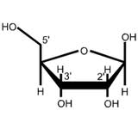
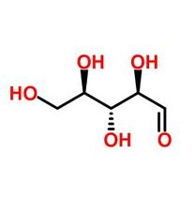
- Bubble the sugar molecule found in DNA.
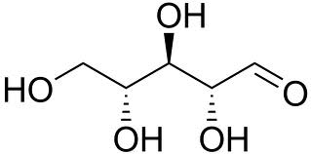
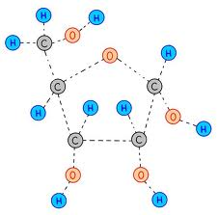
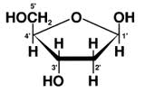

- Bubble the complementary strand of the following DNA leading strand – 5’ TAGGCCT 3’
- 5’ UAGGCCT 3’
- 3’ ATCCGGA 5’
- 5’ ATCCGGA 5’
- 3’ AGGCCTA 5’

- Bubble the nonpolar amino acids.
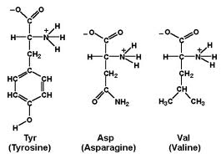

PART 2: Riddle me this
Match the following
- Amino acids a. Beta pleated sheets
- Carbohydrates b. Phosphodiester linkage
- DNA c. Hemoglobin
- Triacyglycerol d. Ester linkage
- Secondary protein e. Glycosidic linkage
- Quaternary structure f. Peptide linkage

- A protein polymer composed of amino acids Threonine and Leucine was dropped in a hydrophobic solution. Which of the following will most likely occur? (structure of the amino acids are below)

- The protein polymer will denature initially and slowly refold over time.
- There will be no change since the protein polymer is composed on Threonin which is non reactive and does not dissolve in non aqueous solution.
- The polymer will refold with Threonine on the outside in contact with the hydrophobic solvent and Leucine on the inside.
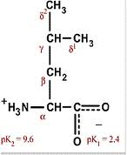
- The polymer will refold with Leucine on the outside in contact with the hydrophobic solvent and Threonine on the inside.
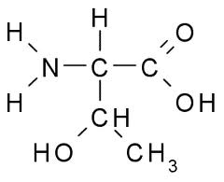
Threonine Leucine

- The molecular formula for glucose is C6H12O6. What would be the molecular formula for a polymer made by linking ten glucose molecules together by dehydration reactions?
- C₆₀H₁₂₀O₆₀
- C₆H₁₂O₆
- C₆₀H₁₀₂O₅₁
- C₆₀H₁₀₀O₅₀
- C₆₀H₁₁₁O₅₁

