Chapter 12
Answer each question below related to mitosis, by selecting the most appropriate answer from the choices given.
1. During which stage of mitosis is the nuclear membrane broken into fragments?
Ο Early Prophase
Ο Metaphase
Ο Anaphase
Ο Late Prophase
Answer:
2. Equatorial plate of the mitotic spindle is formed during the _______.
Ο metaphase
Ο anaphase
Ο late prophase
Ο early prophase
Answer:
3. Mitotic cell division is initiated in the _______.
Ο centriole
Ο centromere
Ο nucleus
Ο mitotic spindle
Answer:
4. During which stage of mitosis do nucleoli reappear?
Ο Telophase
Ο Anaphase
Ο Early Prophase
Ο Late Prophase
Answer:
5. The number of chromosomes in a human cell is _______.
Ο 2
Ο 4
Ο 23
Ο 46
Answer:
6. The resting stage of the cell is known as the _______.
Ο interphase
Ο telophase
Ο anaphase
Ο prophase
Answer:

7. During which stage of mitosis do chromatids separate to form two sets of daughter chromosomes?
Ο Anaphase
Ο Telophase
Ο Prophase
Ο Interphase
Answer:
8. Genetic information is transferred from parent to daughter cells through the _______.
Ο nucleus
Ο mitochondria
Ο endoplasmic reticulum
Ο centrioles
Answer:
9. Which stage of mitosis is depicted in the diagram below?
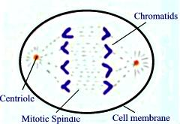
Ο Anaphase
Ο Metaphase
Ο Telophase
Ο Prophase
Answer:
10. Which stage of mitosis is depicted in the diagram below?
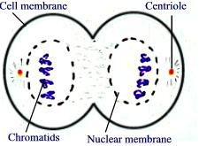
Ο Telophase
Ο Metaphase
Ο Anaphase
Ο Prophase
Answer:

11. Which stage of mitosis is depicted in the diagram below?
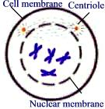
Ο Prophase
Ο Anaphase
Ο Metaphase
Ο Telophase
Answer:
12. Which of the following is the longest stage of mitosis?
Ο Prophase
Ο Telophase
Ο Metaphase
Ο Anaphase
Answer:
13. During which stage of mitosis does longitudinal splitting of the chromosomes occur?
Ο Anaphase
Ο Prophase
Ο Telophase
Ο Metaphase
Answer:
14. The interphase and mitosis together constitute the cell cycle.
Ο True
Ο False
Answer:
15. The nuclear membrane is formed around the newly-formed sets of daughter chromosomes during the telophase.
Ο True
Ο False
Answer:
16. During mitosis, loosely arranged strands of chromosomes become coiled, shortened and distinct during the metaphase.
Ο True
Ο False
Answer:

Questions from www.syvum.com
SI Website: www.elielarrey.com

