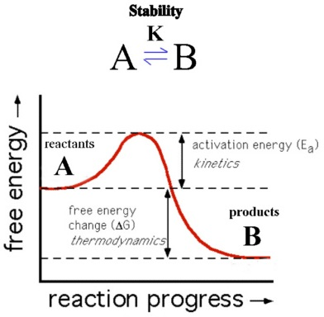
Chapter 7 & 8
Name:
Consider the graph below (Questions 1-9)

- From the graph, the backward reaction occurs
  - Nonsponataneously
  - Spontaneously
  - With a –ΔS
  - With a –ΔH
  - More than one is correct
- An enzyme working on the reaction in the graph works by
  - Increasing free energy
  - Decreasing free energy
  - Increasing activation energy
  - Decreasing activation energy
- Which of the following compounds above is more thermodynamically stable?
  - Compound A
  - Compound B
  - Both A & B
  - Need for information
- Which of the following is true?
  - The backward reaction requires less energy than the forward.
  - The forward reaction is endothermic
  - The activation energy of the backward reaction is greater than the forward
  - The same enzyme acting on the reaction can change the ΔG of the overall reaction.
- Which of the following is incorrect?
  - The forward reaction above is exergonic and energy is released
  - The reaction above will occur spontaneously at very high temperatures
  - The reaction is spontaneous whenever heat (enthalpy) is released
  - The reaction is analogous to Na+ ions pumped along their electrochemical gradient.
- Suppose that the above graph represented the free energy change of a given channel protein along an animal cell membrane. Which of the following will exhibit a function that supports the backward reaction?
  - K+ Facilitated diffusion channels
  - H+ cotransport channels
  - Na+K+ ATPase pump channels
  - Steroid specific diffusion channels
- A certain drug was administered to Compound A at the start of the reaction process, this drug increased the initial ΔG of the reactants but not of the product Compound B. Which of the following is an outcome consistent with the laws of thermodynamics?
  - It will increase the overall kinetic stability of the reaction
  - It will increase the activation energy of the forward reaction
  - It will make the forward reaction less spontaneous and less energy will be released
  - It will increase the total amount of energy available to do work.
- Consider the following reaction, which when plotted on a graph shows a similar thermodynamic pattern as the graph above. Which of the following is true?
C₆H₁₂O₆ + 6 O₂ → 6 CO₂ = 6 H₂O + 2870 kJ of energy
  - The above reaction is endergonic because it requires energy in order to proceed.
  - Each mole of glucose has a standard free energy change of +2870KJ
  - Oxygen is the catalyst of the reaction lowering the activation energy
  - Glucose represents thermodynamic potentiality
- The reaction in graph 1 was calculated by the formula ΔG = ΔH – TΔS. Given that the graph above represents the free energy change of an isolated system, which of the following is correct?
  - ΔG is dependent only on ΔH,
  - ΔG = ΔS, for all isolated systems
  - ΔG = 0, for all isolated systems
  - ΔG = -TΔS for all isolated systems
- It is often said that a picture is worth a thousand words. You are driving down your neighborhood on a beautiful Sabbath morning and you see the following sign posted in front of a local worship house. Which of the following is most likely the intended message by the worship group endorsing the posted sign?
  - All you have to do is recite prayers once a month, little or no additional work is needed.
  - It takes work to be saved, it’s not easy
  - Being saved is mankind’s naturally shared destiny
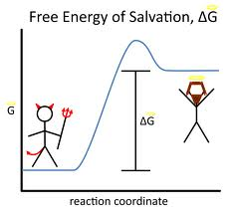
  - Being saved is exergonic, takes lots of energy to maintain salvation

