S.I. Practice TEST 1.
Name:

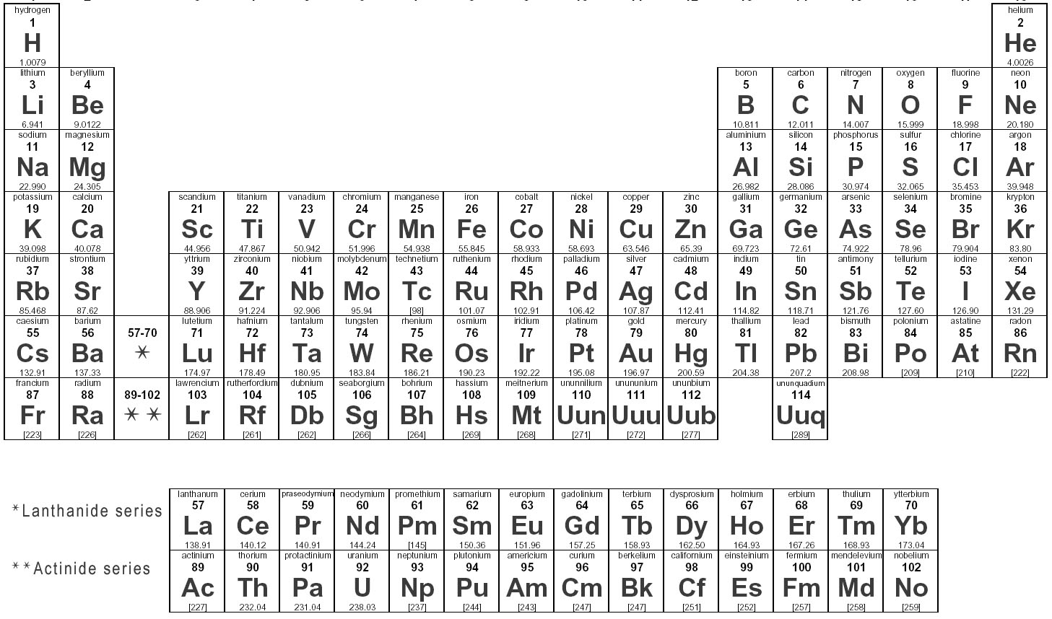

1) Which term best explains the relationship between Cu (Copper) – 63.54amu and Cu – 65.98amu?
A) Isomers
B) Enantiomers
C) Stereoisomers
D) Isotopes

2) What is the valence of an atom with six electrons in its outer electron shell?
A) 1.
B) 2
C) 3
D) 8
E) 6
3) Potassium has an atomic number of 19 and atomic mass of 39.098amu. Therefore, a potassium atom must have…
A) 19 neutrons
B) 20.098 electrons
C) 20.098 protons
D) 6.02 x 10²³
E) 20.098 neutrons
4) Calculate the molarity when 75.0 grams of MgCl₂ is dissolved in 500.0 mL of solution.
A) 1.57 M
B) 0.00157 M
C) 0.788 M
D) 393.90 M
E) 2.48 M

5) Which of the following solutions has the greatest concentration of hydroxide ion?
A) lemon juice at pH 2.0
B) urine at pH 6.7
C) tomato sauce at pH 4.5
D) Seawater at pH 8.0
E) Mtn Dew at pH 8.2
6) A 6 g of Sucrose is dissolved in 350 mL of water. What is the Molarity of the final solution? (Formula for sucrose is C₁₂H₂₂O₁₁)
A) 0.0501M
B) 5 x 10 ^ -5 M
C) 0.350 M
D) 0.1501 M

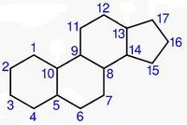
7) The molecule to the right is an example of a , and is in water.
A) Nucleic acid, soluble
B) Nitrogenous base, insoluble
C) Alcohol, insoluble
D) Long chain Hydrocarbon, soluble
E) Hydrocarbon, insoluble
8) Consider a DNA molecule composed of 120 purines and 120 pyrimidine. This molecule could be composed of…
A) 120 Uracil and 120 Adenine
B) 60 Thymine and 120 adenine
C) 120 Adenine and 120 thymine
D) 240 adenine and 240 cytosine
E) C & D
9) A protein polymer composed of amino acids Threonine and Leucine was dropped in a lipophilic solution. Which of the following will most likely occur? (structure of the amino acids are below)

- The protein polymer will denature initially and slowly refold over time.
- There will be no change since the protein polymer is composed on Threonin which is non reactive and does not dissolve in non aqueous solution.
- The polymer will refold with Threonine on the outside in contact with the hydrophobic solvent and Leucine on the inside.
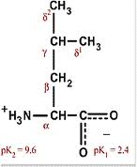
- The polymer will refold with Leucine on the outside in contact with the hydrophobic solvent and Threonine on the inside.
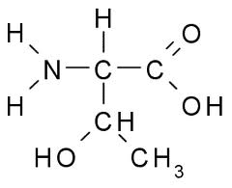
- More than one is correct.
Threonine Leucine -

10) Which of the following organelles contain enzymes that transfer hydrogen from various substrates to oxygen to detoxify them?
A) Lysosome
B) Golgi apparatus
C) Food vacuoles
D) Peroxisomes
E) Mitochondrion
11) Milk of Magnesia has an approximate pH of 10, what is the [H] (hydrogen ion concentration) and pOH of milk of Magnesia?
A) 10⁻⁴M, pOH of 10
B) 10⁻¹⁰M, pH of 4
C) 10⁻¹⁰M, pOH of -4
D) 10⁻¹⁰M, pOH of 4
E) 10⁻⁴M, pH of 10

12) Which of the following is incorrectly paired with its function in Human cells?
A) Flagellum – locomotions
B) Plasma membrane – encloses the cell and contents
C) Mitochondrion – site for intense cellular respiration
D) Cell wall – Maintains cell’s shape and protects cell from mechanical damage
E) Nucleus – Main organelle that regulates all cell activities
(Now go back and recheck your answer!)
13) The molecular formula for glucose is C6H12O6. What would be the molecular formula for a polymer made by linking ten glucose molecules together by dehydration reactions?
- C₆₀H₁₂₀O₆₀
- C₆H₁₂O₆
- C₆₀H₁₀₂O₅₁
- C₆₀H₁₀₀O₅₀
- C₆₀H₁₁₁O₅₁
14) Humans do not digest cellulose and it is passed through the digestive tract and eliminated with feces. What accounts for the fact that animals such as cows and goats are able to digest cellulose in grass?
- Herbivores have different cells lining their gastrointestinal tract that are able to digest cellulose.
- Enzymes in humans that digest starch do so by hydrolyzing the beta linkages in its glycosidic bonds and these same enzymes are unable to hydrolyze the alpha – glycosidic linkages in cellulose.
- Enzymes in humans that digest starch do so by hydrolyzing the alpha linkages in its glycosidic bonds and these same enzymes are unable to hydrolyze the beta – glycosidic linkages in cellulose.
- Humans are unable to convert cellulose to starch, while herbivores are able to convert cellulose into a more absorptive form such as starch, thus explaining the reasoning herbivores undergo regurgitation.
15) Human blood has an average pH of 7.4 under normal physiological conditions. What is the Mole concentration of Hydrogen ions in human blood when diluted in 200mL of distilled water?
A) 4 x 10⁻⁹ moles
B) 8 x 10⁻⁹ moles
C) 5 x 10⁻⁸ moles
D) 2 x 10⁻⁷ moles
E) 2 x 10⁻⁹ moles
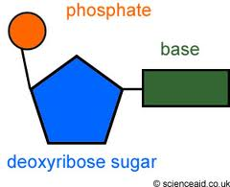
16) Consider the molecule to the far right. Given it undergoes two phosphorylation reactions then carried to the mitochondria ATPase pump where it trades 1 phosphate molecule for every 1 H⁺ ion. What will be the name of the product after 3 H⁺ ions are released from the mitochondria matrix?
A) A simple DNA nucleotide
B) A diphosphorylated DNA nucleotide
C) A triphosphorylated DNA nucleoside
D) A simple nucleoside
E) A diphosphorylated DNA nucleoside
17) Which of the following is true for both starch and cellulose?
A) They are both components of chitin
B) They are both used for energy in plants
C) They can both be digested by humans
D) They are structural components of plant cell wall
E) They are both polymers of glucose
18) Doing which of the following will result in the production of a carbonyl group?
A) the addition of a thiol to a hydroxyl
B) the replacement of the nitrogen of an amine with oxygen
C) the replacement of the OH on a carboxyl group with hydrogen
D) the addition of a hydroxyl to a phosphate
E) addition of a sufhhydryl to a glucose sugar alpha carbon
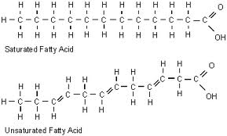
19) Consider the molecule below:

- Saturated fatty acids (SFA) are liquid at room temperature while polyunsaturated fatty acids (PUFA) are solid at room temperature.
- PUFA’s have higher freezing points than SFA’s.
- SFA’s have lower boiling points than PUFA’s
- Saturated fatty acids (SFA) are solid at room temperature while polyunsaturated fatty acids (PUFA) are liquid at room temperature.
- B & D
20) Tay–Sachs disease (abbreviated TSD, also known as GM2 gangliosidosis or Hexosaminidase A deficiency) is an autosomal recessive genetic disorder. The disease occurs when harmful quantities of gangliosides accumulate in the nerve cells of the brain, eventually leading to the premature death of those cells. Which organelle of the brain cell of a Tay-Sachs patient is defected?
A) Golgi Apparatus
B) Smooth Endoplasmic reticulum
C) Lysosomes
D) Nucleolus
E) Ribosomes
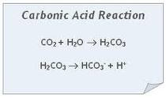
21) Consider the reaction: Assume reactions are at equilibrium. Which statement is correct?

A) Increasing CO2 concentration will decrease the pH of resulting solution.
- Increasing the pOH will increase the amount of CO2 being discharged.
- The forward and backward reaction products occur at the same concentration
- The rate of the forward reaction is greater than the rate of the backward reaction.
- A & D
22) Given a solution with a pH of 9, a solution of equal volume with pH 4 has how many more H ions?
A) 10,000 times more
B) 100 times more
C) 10 times more
D) 100,000 times more
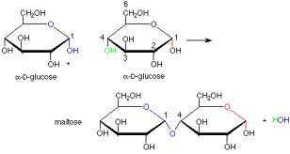
E) 100,000,000 times more
23) Identify the chemical reaction taking place.
- Hydrolysis of glucose
- Dehydration of maltose
- Dehydration of glucose
- Hydrolysis of maltose

24) You are instructed to create a polymer of 168 glucose molecules, upon completion you are instructed to collect the data on all your products. One of the side products in the reaction was water, how many glycosidic bonds exist in your polymer and how many moles of water were collected?
A) 168 glycosidic bonds, and 168 moles of H₂O
B) 167 glycosidic bonds, and 168 moles of water
C) 167 glycosidic bonds, and 334 moles of H₂O
D) 169 glycosidic bonds, and 169 moles of H₂O
E) 167 glycosidic bonds, and 167 moles of H₂O
25) A covalent bond is one in which…
A) electrons are removed from the more electronegative atom to the less electronegative in order to form a complete octet.
B) Protons and neutrons are shared between two atoms until a complete and stable compound is formed.
C) Outer shell electrons of two atoms are transferred to the inner shell of the more electronegative atom
D) Outer electrons of two atoms are shared between the two atoms to fill their outer electrons shells unto the formation of a stable octet.
E) Outer shell electrons are shared but a majority of the electrons reside close to the outer shell of the more electronegative atom of the two original atoms.
26) From questions # 25, which of the answer choices defines a polar covalent bond?
A)
B)
C)
D)
E)
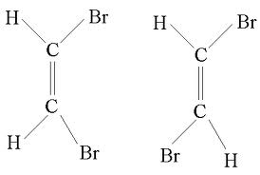
27) Which of the following best describes the relationship between the molecules below?
- They are also known as structural isomers.
- The first one is called a trans and the second cis.
- They are also known as geometric isomers.
- The first molecule carries not net dipole charge, while the
Latter carries a net dipole.
- A & D
28) Which of the following statements correctly describes geometric isomers?
A) They have different molecular formulas
B) They have an asymmetric carbon that makes them mirror images
C) They have the same chemical properties
D) They have variations in arrangement around a double bond.
E) They differ in electrical charge.
29) Which cell structure is in both plant cells and animal cells?
A) Food vacuoles
B) Chloroplasts
C) Lysosomes
D) Centrioles
E) Mitochondrion
30) Rivers do not freeze solid in winter because
A) Water does not freeze easily due to H bonding
B) Water has a high specific heat capacity
C) Water freezes at 4º
D) Water is densest at 4º
E) Water is densest at 0º
31) Which structure is found in both prokaryotes and eukaryotic cells?
A) Mitochondrion
B) Ribosome
C) Nuclear membrane
D) ER
E) B & C
32) When two atoms are equally electronegative, they will interact to form
A) ionic bonds
B) polar covalent bonds
C) ions
D) polar covalent bonds with no ionization energy
E) non polar covalent bonds
33) If a DNA molecule was composed of 18% thymine, what would be the percentage of cytosine?
A) 18%
B) 36%
C) 64%
D) 32%
E) 68%
34) Which of the following are actions one would expect from a pH buffer regulating system such as that present in question # 21?
A) releasing H+ in acidic solutions
B) donating H+ to a solution with depleted amounts of H+ ions
C) accepting OH- when they are in shortage
D) accepting H+ when they are in excess
E) B & D
35) Which of the following is not found in RNA?
- Thymine
- Uracil
- Adenine
- Cytosine
- All are present in RNA
36) Which of the following is incorrectly paired with its function?
A) Ribosomes – DNA transcription
B) Smooth ER – synthesis of lipids
C) Chloroplasts – cellular respiration
D) B & C
E) A & C
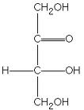
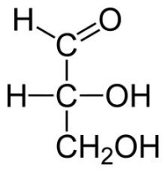
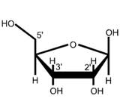
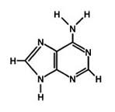
Refer to figures for questions 37 – 42
A. B. C. D.

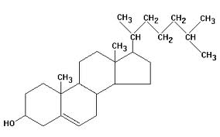
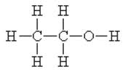
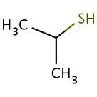
E. F. G.

37) Which molecule acts as a base?
38) Which molecule is an aldehyde?
39) Which molecule stabilizes protein structures?
40) Which molecule is a ketose?
41) Which molecule is an alcohol?
42) Which molecule will be a good candidate to increase the pH of a solution?
43) The complementary strand of the following DNA leading strand – 5’ TAGGCCT 3’
- 5’ UAGGCCT 3’
- 3’ ATCCGGA 5’
- 5’ ATCCGGA 5’
- 3’ AGGCCTA 5’
44) Of the following molecules of the ECM (extracellular matrix), which is capable of transmitting signals between the cell’s external environment and it’s intracellular space?
A) Proteoglycan complex
B) Fibronectin
C) Integrins
D) Collagen fibers
E) Plasmodesmata
45) Four protein molecules containing both polar and non polar side chains (R groups) are placed in aqueous salt solution. Given that folding begins almost immediately following insertion into salt solution, at which level of protein structure will interactions with side chains occur?
A) Primary
B) Quarternary
C) Secondary
D) Tertiary
E) B & D only
46) Which is responsible for maintenance of the alpha helix protein structure?
A) Peptide bonds
B) disulfide bonds
C) hydrogen bonds
D) Ester bonds
E) Phosphodiester bonds
47) Which cell would be best and most appropriate for studying lysosomes?
A) Muscle cell
B) Adipose cell
C) Nerve cell
D) Phagocytic white blood cell
E) Bacterial Cell
48) Which of the following will result when a DNA molecule is treated with a highly reactive hydrolytic enzyme?
A) The two DNA strands will separate into individual polymers.
B) The pyrimidines would be separated from the deoxyribose sugars.
C) The purines would be separated from the ribose sugars.
D) The phosphodiester linkages between the ribose sugars would be broken.
E) The phosphodiester linkages between the deoxyribose sugars would be broken.
49) Monoclonal Anti-Protein A is an anti body produced in mice responsible for disrupting the H bonding in viral protein structures. Which structural protein will be least affected by this agent if this Anti-Protein was released into your blood stream?
A) Primary level
B) Secondary level
C) Tertiary level
D) Quaternary level
E) All are affected by the Anti-Protein
50) A 12 g of Mg is dissolved in 250 mL of water. What is the Molarity of the final solution?
A) 4M
B) 2M
C)1152M
D) 0.002M
E) 0.02M

If done before the time runs out, you can GO BACK AND CHECK YOUR WORK!

GOOD LUCK on Monday!
SI Website: http://www.elielarrey.com/biology-1441.html
SI Forum: http://elielarrey.lefora.com/
Feel free to contact me for any question via SI website.

